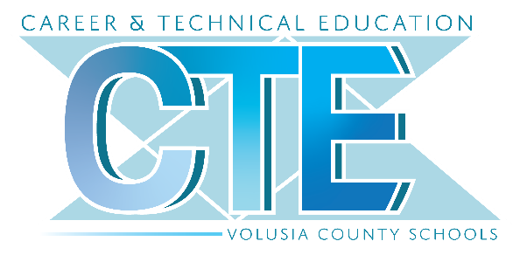
PARENT PROCESS TO APPLY
Parents/guardians whose student meets the grade level requirements will be able to apply for Career Academy programs through the Parent Portal.

The Career Academy Application 2023 will appear for the parent under their child’s name in the left-side menu on their Parent Portal.
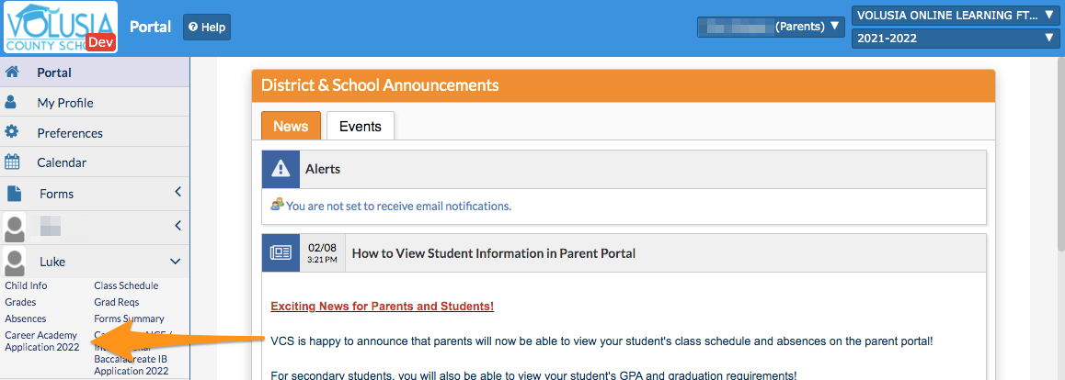

Your student’s demographic and contact information will be located at the top of the application.
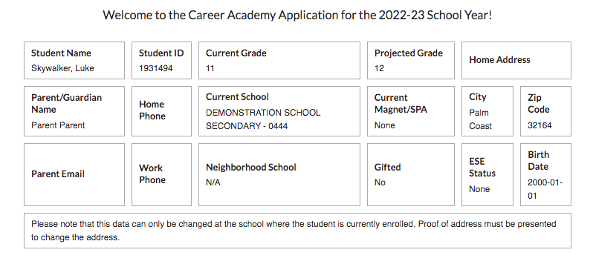

Please read the Agreement of Understanding and select your response from the dropdown.

In next box, please select the Academy you wish to apply to. You may make up to three choices. Each Academy can only be selected once.
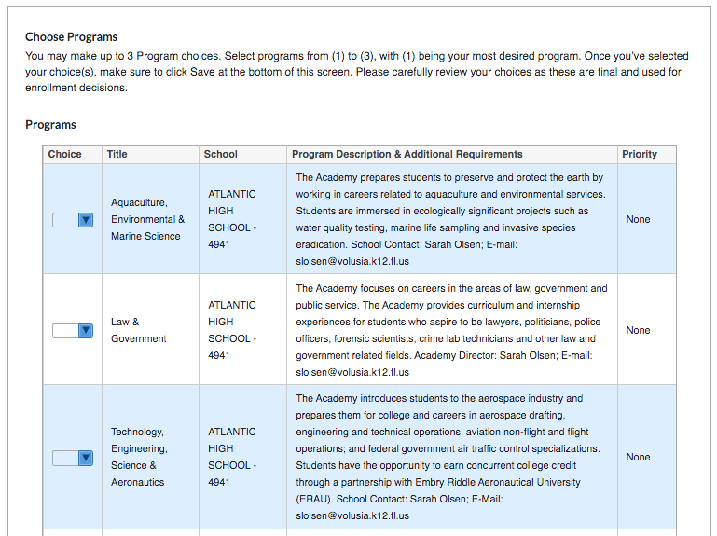

To complete the process the please select Save or Save & Print. Once the application is Saved it has been Submitted.
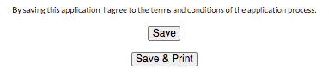

A confirmation email will be sent to the email address on file for the Parent Portal account once the application is submitted.

